Poster 7
Synthetic Pathways Leading to novel types of Phosphahelicenes
Tomáš Beránek,¹ Jan Sýkora¹, Jaroslav Žádný,¹ Jan Storch*’¹
¹1nstitute of Chemical Process Fundamentals, v.v.i., Rozvojová 1/135,
Prague 6, 165 02
e-mail: beranekt@icpf.cas.cz
Helicenes possess a helical conjugated polyaromatic system consisting of ortho-fused benzene rings as a fundamental property of these fascinating compounds. Due to this, they also exhibit interesting physicochemical properties including P-type conductivity and enormous optical activity. Helicene chemistry is being considered as an expanding and modern field of research, leading to various applications, which can be further extended by the introduction of heteroatom directly into the helical skelet^{1,2}. Very interesting seems to be the combination of the extraordinary properties of helicenes and the presence of phosphorus atom to form new types of phosphahelicenes. The goal of this work is to explore possible synthetic ways leading to these new members of the helicene family.
Scheme 1
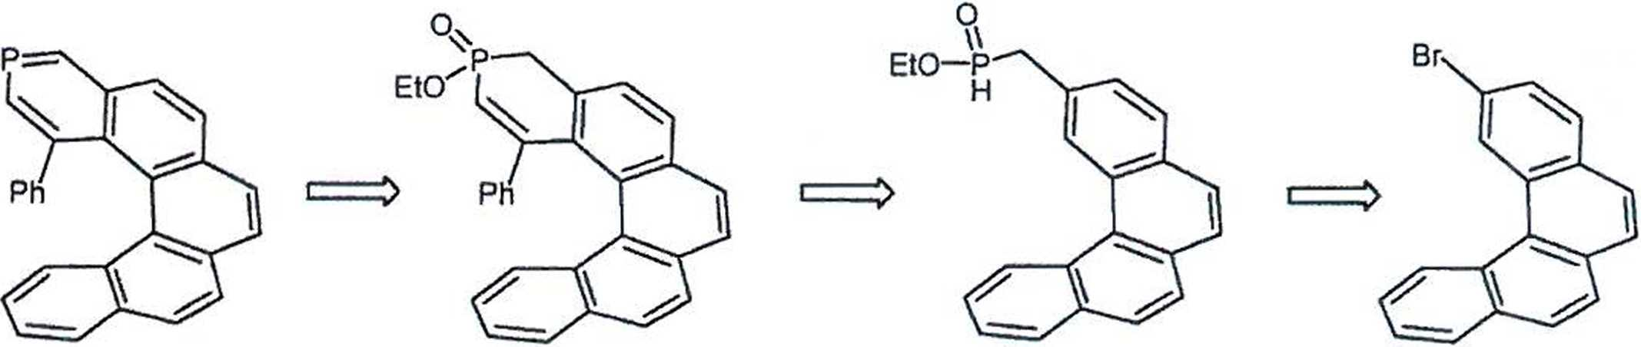
This work was supported by Ministry of Industry and Trade (FV10082).
1 Gingras, M. Chem. Soc. Rev. 2013, 42, 1051.
2. Aillard, P.; Voituriez, A.; Marinetti, A. J. Chem. Soc., Dalton Trans. 2014, 15263.
63

